**Aici va fi cover page-ul.**

**Pana una, alta, aici gasiti instructiuni:**

1. **Veti lucra cu heading-uri, pentru ca cuprinsul sa se genereze automat – va rog sa nu scrieti manual nimic in pagina de cuprins**
2. **Fonturi:**
   1. **Heading 1 – Times New Roman 16 bold center**
   2. **Heading 2 – Times New Roman 14 bold**
   3. **Heading 3 – Times New Roman 12 italic**
   4. **Paragrafe - Times New Roman 12**
   5. **Text descriptiv imagine – Times New Roman 8 italic**
3. **Fiecare imagine va fi cat mai mica posibil – indeajuns incat sa se vada scrisul**
4. **Sub fiecare imagine se va scrie cu italic** *Fig.* **<*numar*>. <***Text reprezentativ***>**

Contents

**I.** **Requirements** 4

**II.** **Application** 5

**II.1. Authentication** 5

**II.2. Navigation menus** 5

*II.2.1. Administration menu* 5

*II.2.2. Client menu* 7

**II.3. User Management** 8

*II.3.1. User creation* 8

*II.3.2. User List* 9

*II.3.3. User Update* 9

*II.3.4. User Deletion* 10

II.4. Workout Management 11

*II.4.1. Workout creation* 11

*II.4.2. Workout List* 12

*II.4.3. Workout Update* 13

*II.4.4. Workout Deletion* 13

II.5. Subscription Management 14

*II.5.1. Subscription creation* 14

*II.5.2. Subscription List* 15

*II.5.3. Subscription Update* 16

*II.5.4. Subscription Deletion* 16

II.6. Room Management 17

*II.6.1. Room List* 17

*II.6.2. Room Creation* 18

*II.6.3. Room Update* 19

*II.6.4. Room Deletion* 20

II.7. Timetable Management 21

*II.7.1. Timetable Entry Creation* 21

*II.7.2. Timetable Entry List* 22

*II.7.3. Timetable Entry Update* 22

*II.7.4. Timetable Entry Deletion* 22

# **Requirements**

***Copiati requirements din github***

# **Application**

## **II.1. Authentication**

***Descriere pagini de login/logout***

## **II.2. Navigation menus**

### *II.2.1. Administration menu*

***In ce context se vede meniul de administrare?***

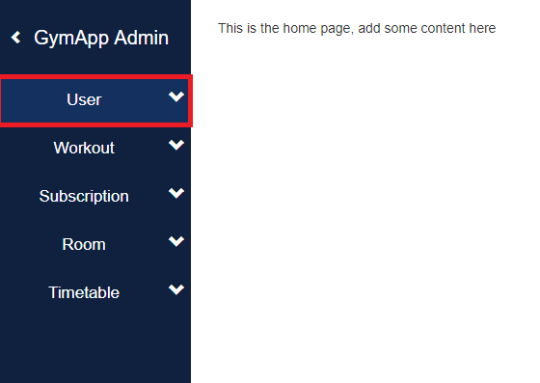

On the left side of the application, you can always find the navigation pane.

In order to view the subitems of a specific item, click on the desired item, like the one marked with red in the picture.

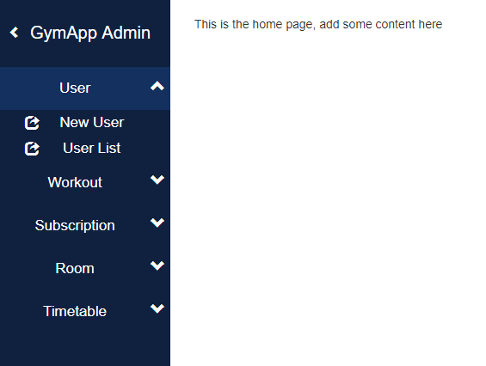

What you will then see are the subitems of the selected item. You can now navigate to different pages regarding the item, like creating a new entry or seeing all entries of that type.

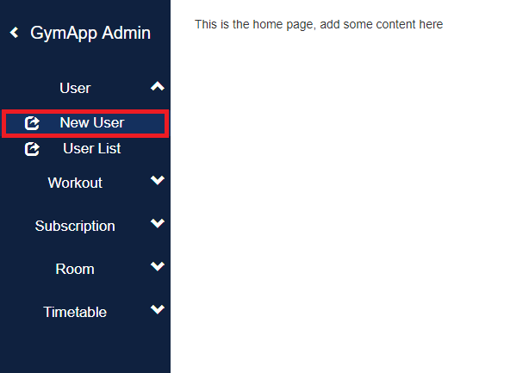

Click on one of the subitems, like the one marked in red, to navigate to the corresponding page.

Then, you will be presented with the selected page.

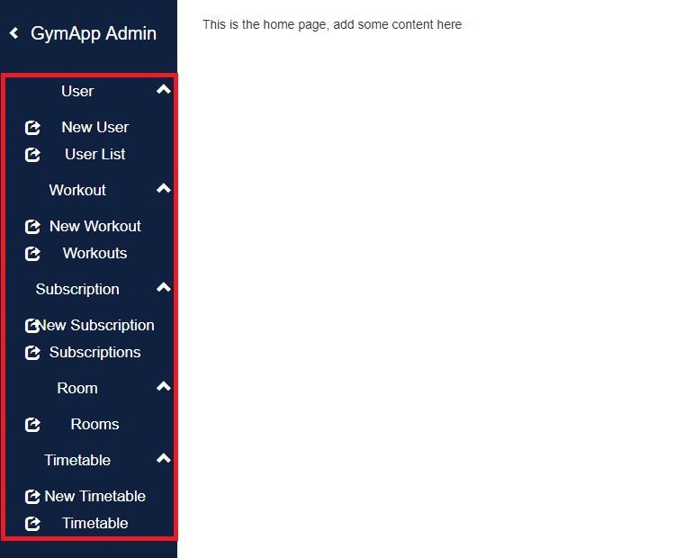

These are all the options you can choose at the moment. ***Ca si administrator. E necesar un print screen si pt trainer***

You can have all navigation items expanded at the same time.

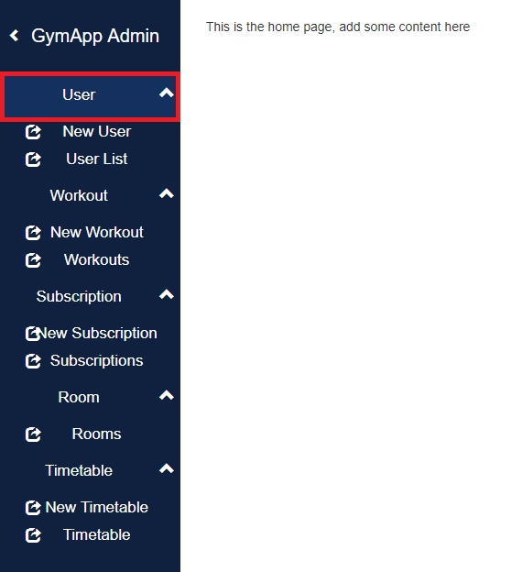

If you want to collapse the items again, just click on one of them.

### *II.2.2. Client menu*

***Inca nu e facut, standby***

## **II.3. User Management**

In this part you will be given information about the management of users of the gym application. The following functionalities will be included:

* Create New User
* User List
* Update User
* Delete User.

In order to access the user management pages, the user has to be authenticated, and have administrative or trainer rights. You can access these functionalities by selecting the „User” option from the menu. Selecting „User” from the menu will allow you to access the next two options: New User and Users.

### *II.3.1. User creation*

If you want to create a new user you will have to follow the next steps.

1. Click on “New User” (this will take you to another page).

2. Write in the user's data.

3. Click on the button "Submit".

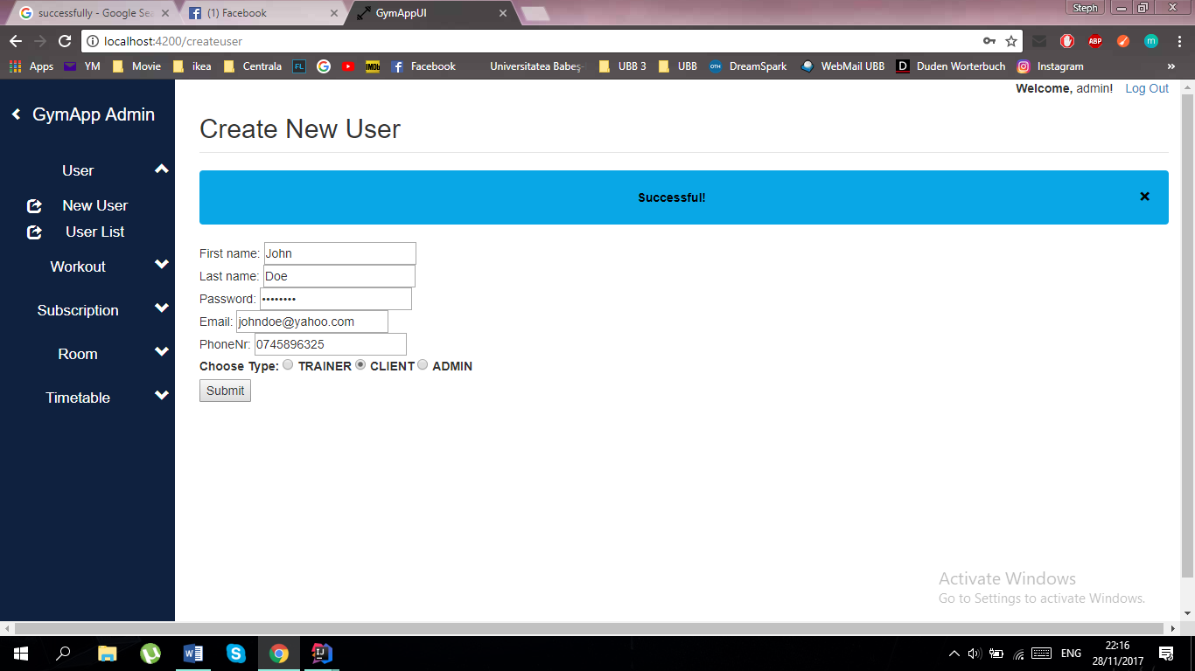

If the user was created successfully then you will receive a confirmation message at the top of the page.

***Necesara diferentierea intre tipurile de user***

### *II.3.2. User List*

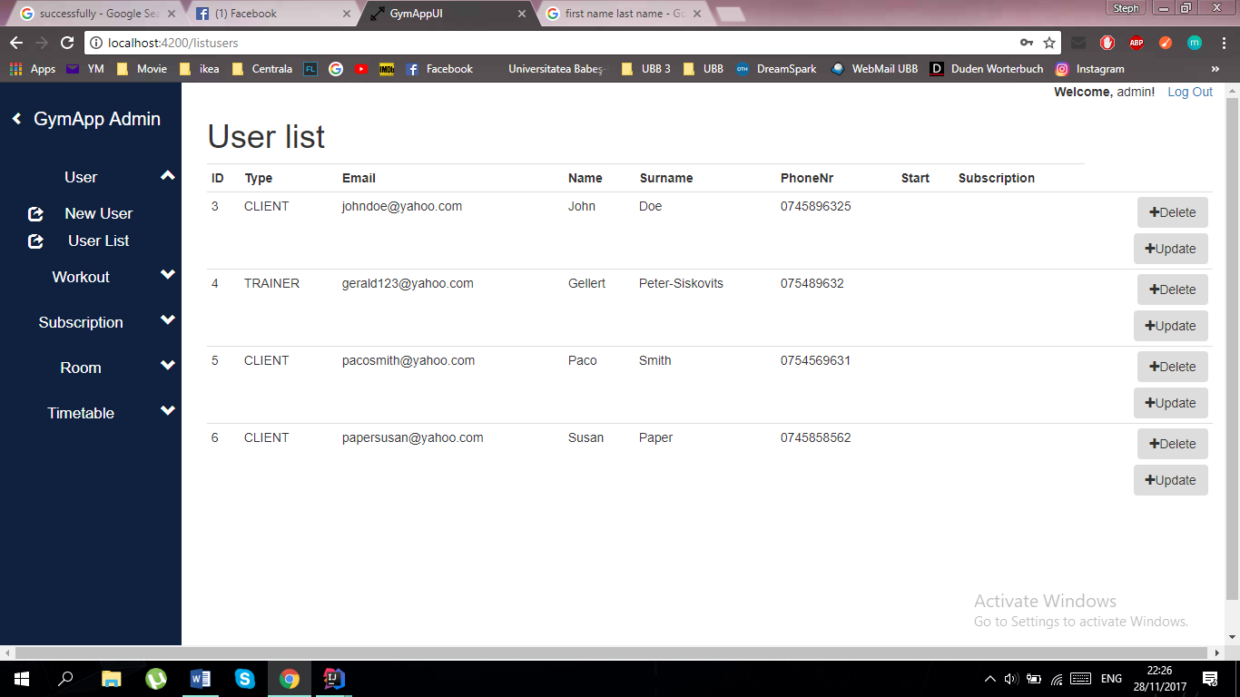Once you clicked on “User List”, the application will show you the list of users that are currently using GymApp. Information about these users are also shown.

***In ce context nu sunt goale start si subscription?***

### *II.3.3. User Update*

If some information about a specific user needs to be changed, then this can be easily done with the help of the button “Update”, which is located on the right side of the (User List) page, next to the user’s infos.

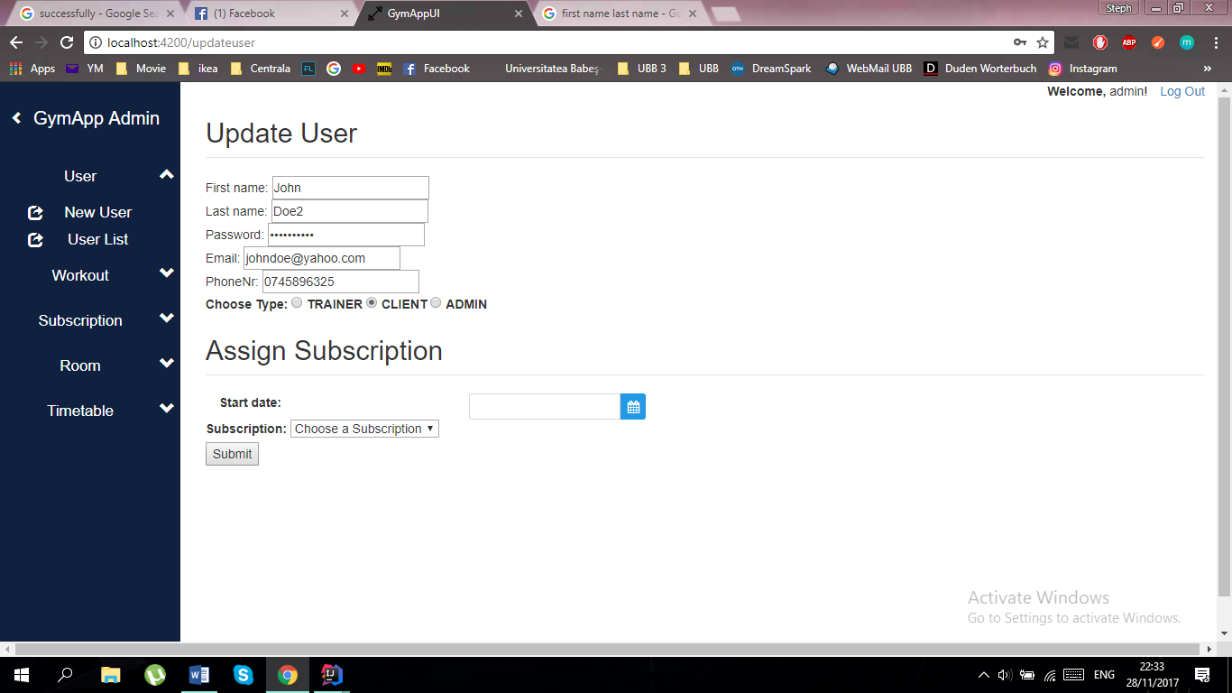On the Update User page you can update the information for a certain user. After finishing with the updates for a specific user, the changes will be updated after one click on the “Submit” button.

A message will appear if the update was done successfully.

### *II.3.4. User Deletion*

When a particular user needs to be deleted, this can simply be done by using the “Delete” button, which is located on the right of the (User List) page, above the “Update” button. One click on the button will delete the user that is no longer needed and a confirmation message will be shown.



## II.4. Workout Management

In this part you will be given information about the management of workouts of the gym application. The following functionalities will be included:

* Create New Workout
* Workout List
* Update Workout
* Delete Workout.

In order to access the workout management pages, the user has to be authenticated, and have administrative rights. You can access these functionalities by selecting the „Workout” option from the menu. Selecting „Workout” from the menu will allow you to access the next two options: New Workout and Workouts.

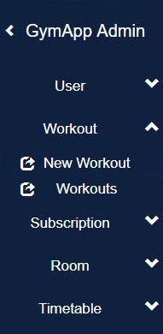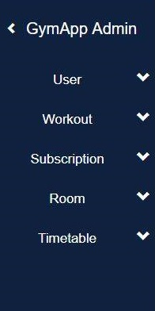

### *II.4.1. Workout creation*

In order to create a new workout please select the option „New Workout” from the submenu. Accessing this option will display the following page:

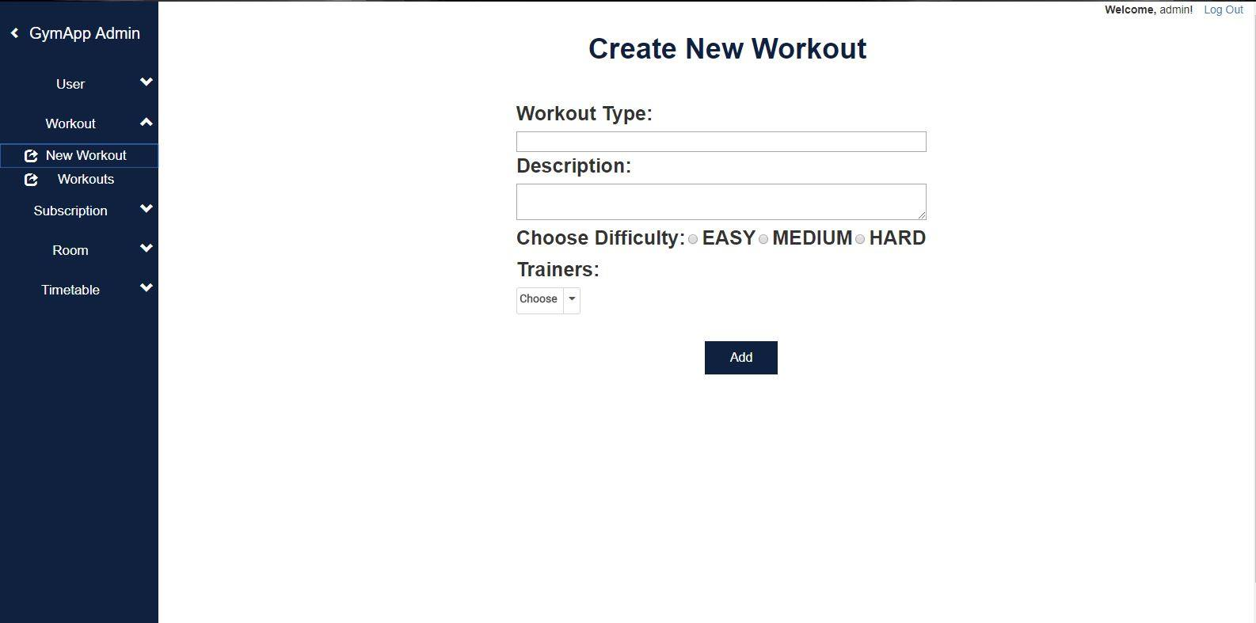



2

1

4

3

In order to create a new workout please complete the fileds *1 and *2, select the difficulty *3 and choose a trainer from the list of trainers 4*.

In order to complete the operation click the „Add” button. ***Success message?***

### *II.4.2. Workout List*

The list of workouts can be viewed from the menu by selecting "Workouts". This option allows you to view and manage the workouts of the gym. Accessing this option will display the following page:

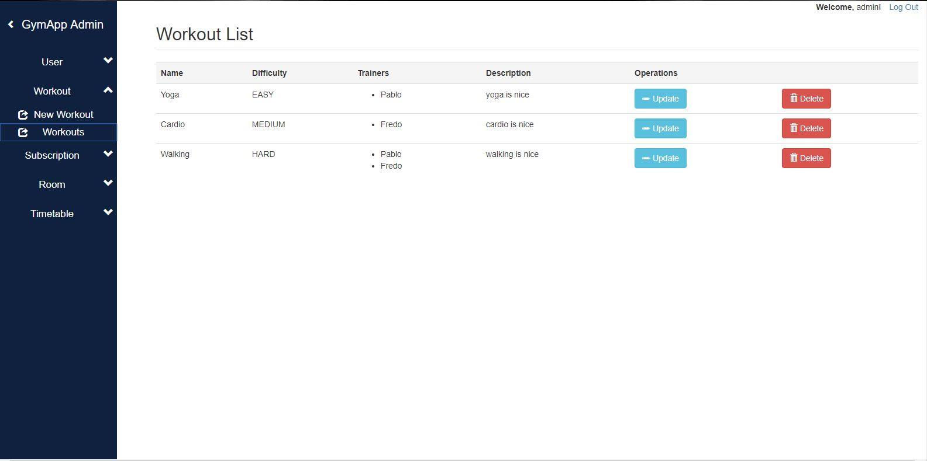

The „Delete” button allows you to delete a specific workout.

### *II.4.3. Workout Update*

If some information about a specific workout needs to be changed, then this can be easily done with the help of the button “Update”, which is located on the right side of the (Workout List) page. By clicking this button, you will be redirected to a new page where you can choose the fields to be modified.

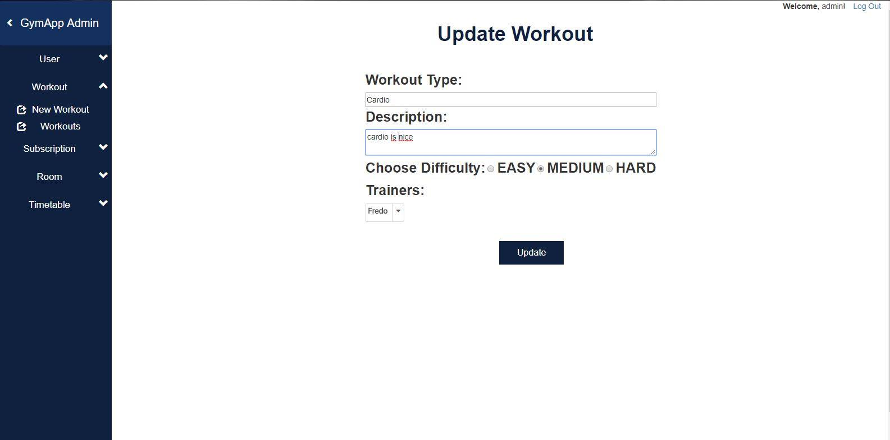

4

3

2

1

In order to update a specific workout enter new values in the fileds *1 and *2, select a new difficulty *3 and choose new trainers from the list of trainers 4*.

In order to complete the operation click the „Update” button. ***Success message?***

### *II.4.4. Workout Deletion*

***Explicatii analog cu User Deletion***

## II.5. Subscription Management

In this part you will be given information about the management of subscriptions of the gym application. The following functionalities will be included:

* Create New Subscription
* Subscription List
* Update Subscription
* Delete Subscription.

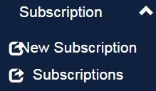 In order to access the subscription management pages, the user has to be authenticated, and have administrative rights. You can access these functionalities by clicking on “Subscription” in the main menu, a drop down menu will open which will give you two choices: “New Subscription” and “Subscriptions”.

### *II.5.1. Subscription creation*

The “New Subscription” option gives you the choice to create a new custom subscription, where you can set a name, price, duration and select the desired workouts from a drop down.

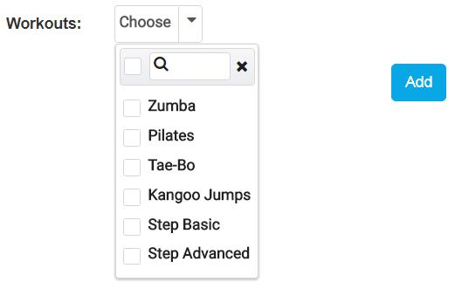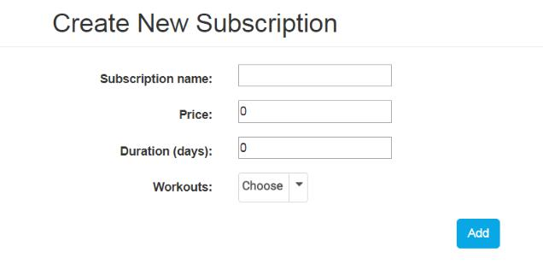

Click the “Add” button after completing all the fields. If the creation is completed, a new subscription will be added to the data base and you will see a “Successful” message.

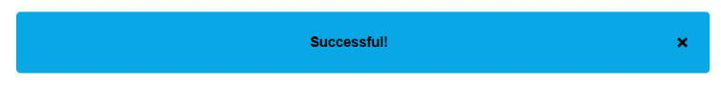Close the pop-up by pressing the x button on the right-hand side.

### *II.5.2. Subscription List*

The list of subscriptions can be viewed from the menu by selecting "Subscriptions". This option allows you to view and manage the subscriptions of the gym. Accessing this option will display the following page:

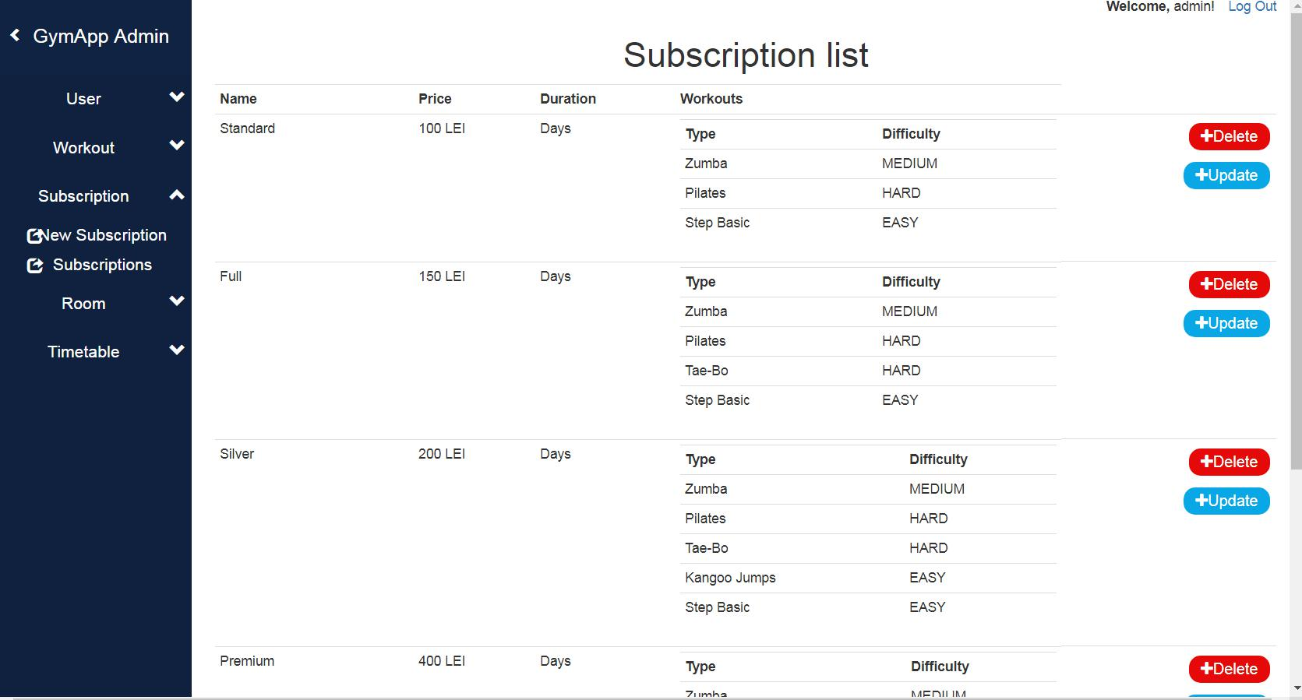

The Subscriptions list displays all the possible subscription types together with their details. The user has the possibility to Delete or Update a subscription.

### *II.5.3. Subscription Update*

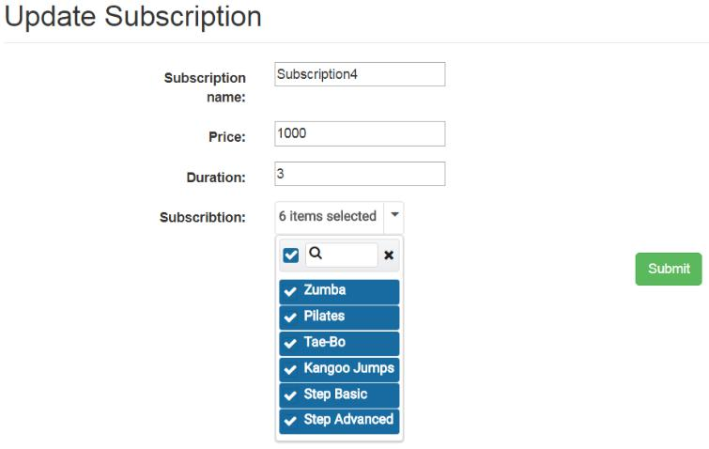By clicking on one of the “Update” buttons in the subscription lists, you will be redirected to the Update Subscription page. Here you can modify all the details of a subscription (name, price, duration and the type-list by selecting multiple workouts).

Press the “Submit” button in the bottom right-hand corner after completing all the fields. When the subscription is up to date you will see the “Successful” pop-up.

### *II.5.4. Subscription Deletion*

***Explicatii analog cu User Deletion***

## II.6. Room Management

In this part you will be given information about the management of rooms of the gym application. The following functionalities will be included:

* Create New Room
* Room List
* Update Room
* 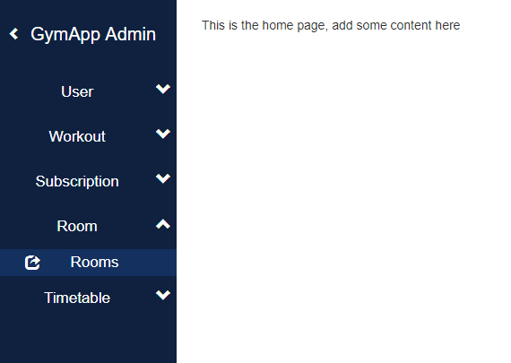Delete Room.

In order to access the room management page, the user has to be authenticated, and have administrative rights. You can access these functionalities by selecting the „Room” option from the menu, and then clicking on “Rooms” to get to the room page.

### *II.6.1. Room List*

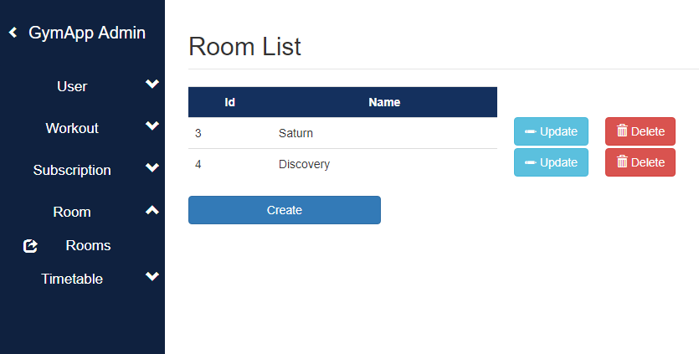You have now arrived at the room page. Here you can manipulate the entries from the database in various ways. This is the list of all rooms.

.

### *II.6.2. Room Creation*

To create a new room, click on the Create button.

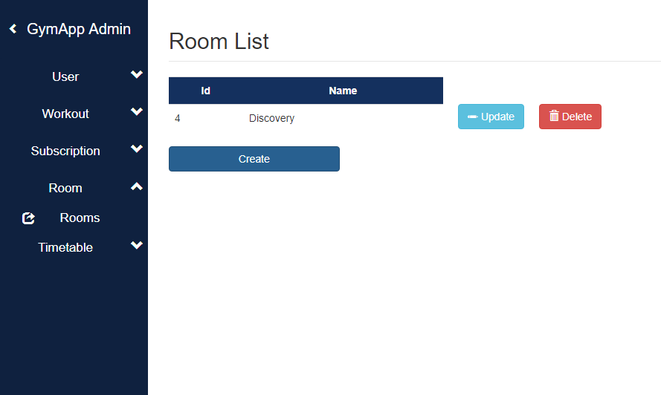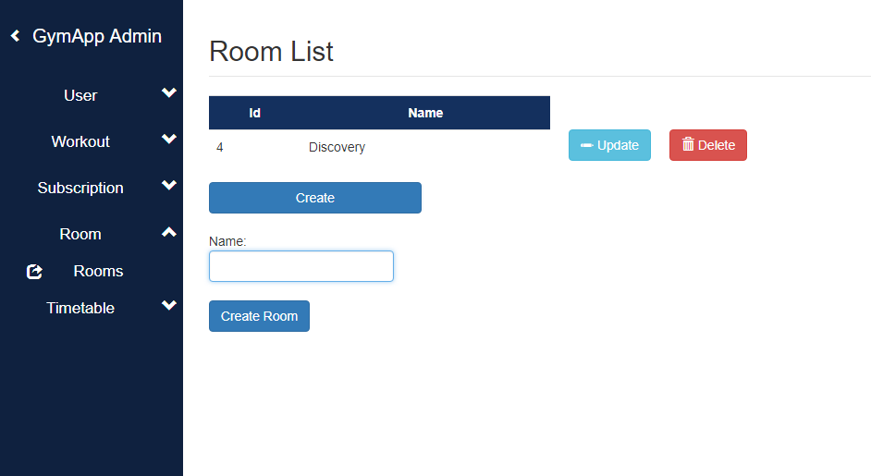

A textbox and a “Create Room” button will appear.

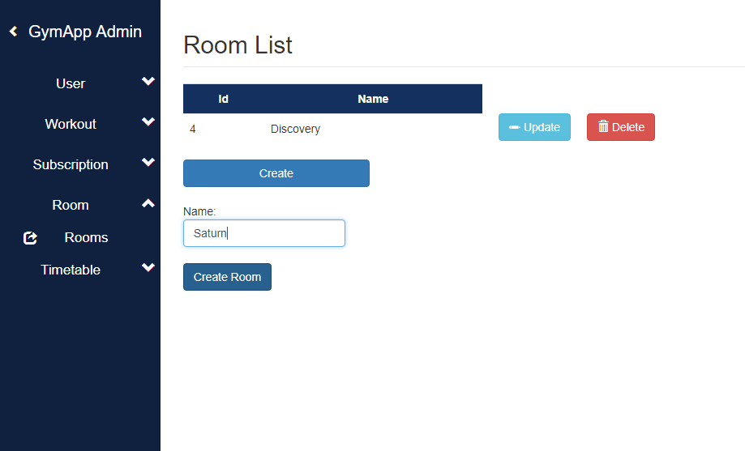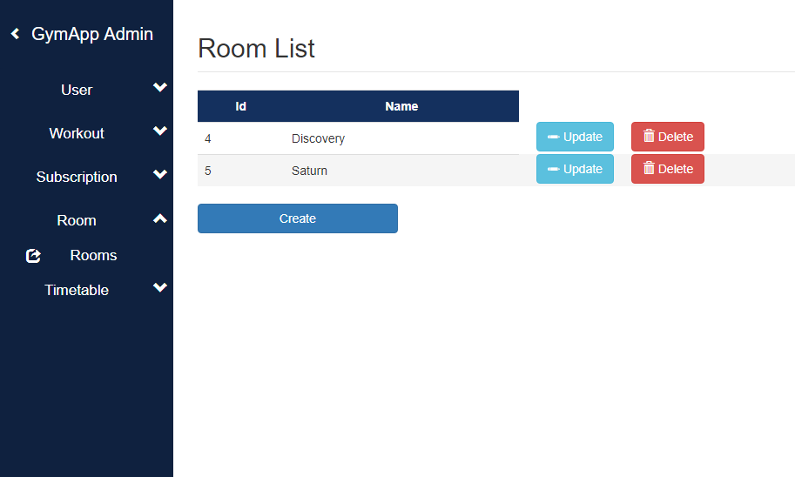

Fill in the room name in the textbox and click on Create Room.

A new room with the given name will be created.

### *II.6.3. Room Update*

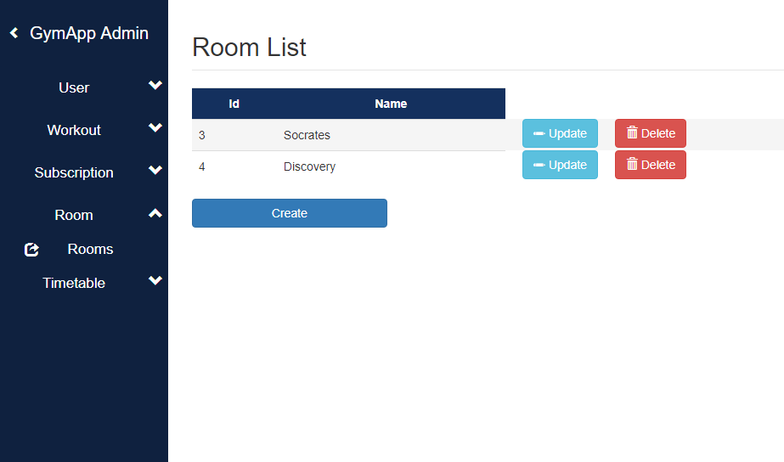

Click on the update button next to a room to quickly change its name.

For example, let’s change “Saturn” to “Socrates”.

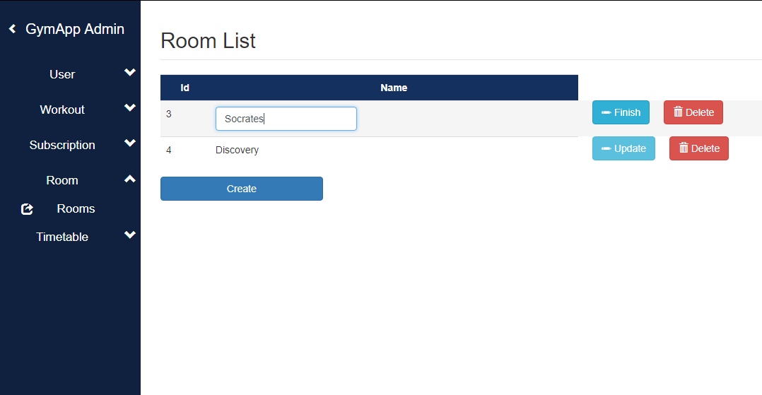

After clicking the update button, the text will become an editable textbox. Click on it and edit the text. After you’ve finished editing the text, click on finish.



Here you can see that the name of the room was updated.

### *II.6.4. Room Deletion*

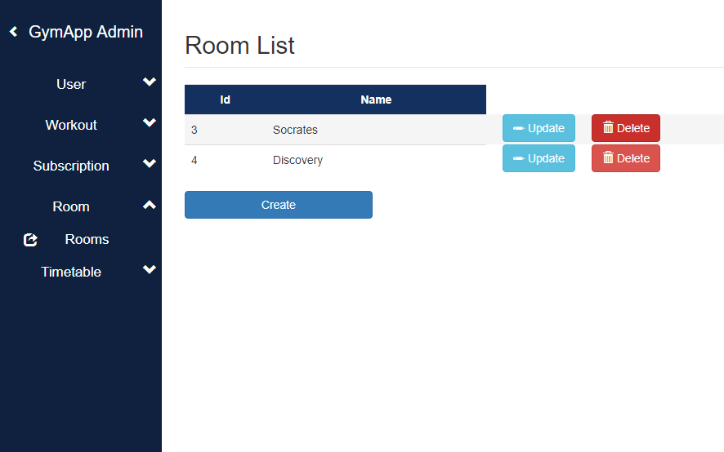To delete a room, just click on the delete button next to it.

As you can see, the room has now been deleted from the list.

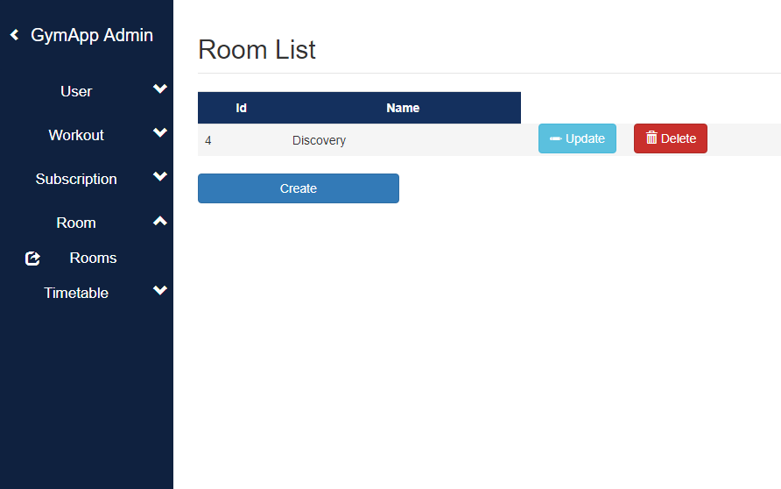

## II.7. Timetable Management

In this part you will be given information about the management of timetable entries of the gym application. The following functionalities will be included:

* Create New Timetable Entry
* Timetable Entry List
* Update Timetable Entry
* Delete Timetable Entry.

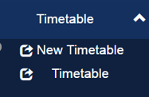 In order to access the timetable management pages, the user has to be authenticated, and have administrative rights. You can access these functionalities by selecting the „Timetable” option from the menu. The timetable component contains two options: one to create a new timetable entry and one to administrate all the existing timetable entries.

### *II.7.1. Timetable Entry Creation*

In order to create a new timetable entry, you will have press on the first option “New Timetable” and to fill the given brackets: the day, the starting hour, the duration, the room and the workout type.

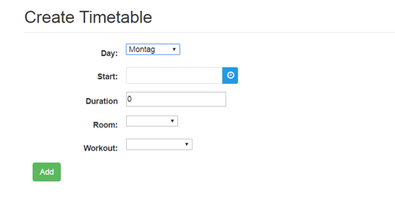

After completing all the necessary information, you will have to press on the “Add” button and your timetable entry will be successfully created. A success message will be displayed, if the new entry has been successfully saved in the database.

### *II.7.2. Timetable Entry List*

In order to access the list of all your timetables entries, you have to choose the second option “Timetable” from the “Timetable” dropdown. 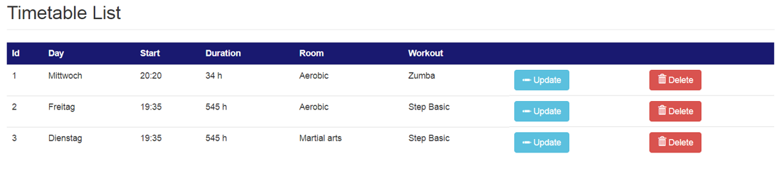

On this page you have the option to alter a timetable entry by pressing the “Update” button or to erase a one by pressing the “Delete” button.

### *II.7.3. Timetable Entry Update*

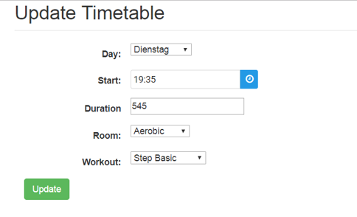By pressing the “Update” button on a timetable entry in the timetable entries list, a new page will be opened where you can see and alter all the details about that specific entry.

Here you have the possibility to alter the day, the starting hour, the duration, the room and the workout type of that timetable entry.

In order to save all the modifications you will also have to press the Update button. If the update has succeeded in the database, a success message will be displayed.

### *II.7.4. Timetable Entry Deletion*

***Explicatii analog cu User Deletion***